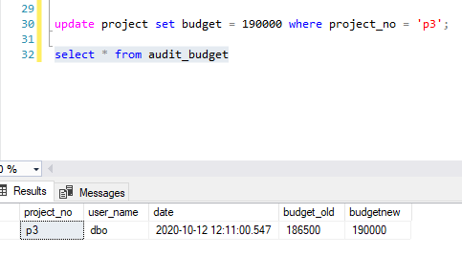

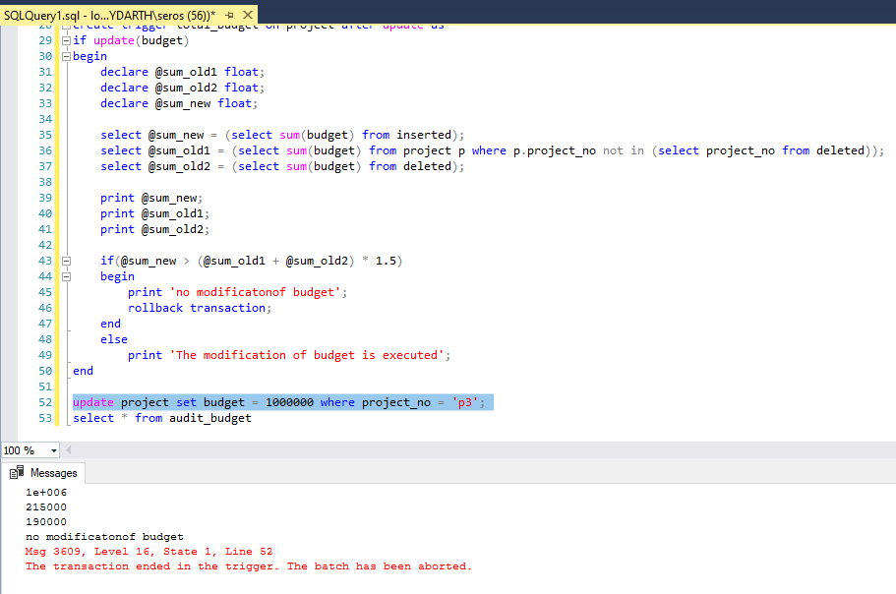

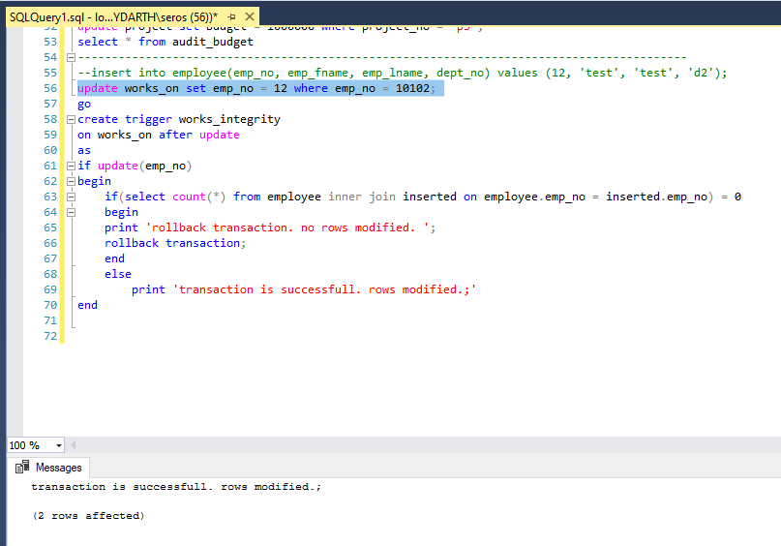

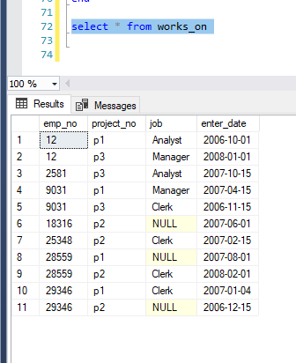

create table audit_budget

(

project_no char(4) null,

user_name char(20) null,

date datetime null,

budget_old float null,

budgetnew float null

);

go

create trigger modify_budget

on project

after update

as

if update(budget) begin

declare @old_budget float;

declare @new_budget float;

declare @project_no char(4);

select @old_budget = (select budget from deleted);

select @new_budget = (select budget from inserted);

select @project_no = (select project_no from inserted);

insert into audit_budget values (@project_no, USER_NAME(), GETDATE(), @old_budget, @new_budget);

end

------------------------------------------------------------------------------------------------------

go

create trigger total_budget on project after update as

if update(budget)

begin

declare @sum_old1 float;

declare @sum_old2 float;

declare @sum_new float;

select @sum_new = (select sum(budget) from inserted);

select @sum_old1 = (select sum(budget) from project p where p.project_no not in (select project_no from deleted));

select @sum_old2 = (select sum(budget) from deleted);

print @sum_new;

print @sum_old1;

print @sum_old2;

if(@sum_new > (@sum_old1 + @sum_old2) * 1.5)

begin

print 'no modificatonof budget';

rollback transaction;

end

else

print 'The modification of budget is executed';

end

update project set budget = 1000000 where project_no = 'p3';

select * from audit_budget

------------------------------------------------------------------------------------------

--insert into employee(emp_no, emp_fname, emp_lname, dept_no) values (12, 'test', 'test', 'd2');

update works_on set emp_no = 12 where emp_no = 10102;

go

create trigger works_integrity

on works_on after update

as

if update(emp_no)

begin

if(select count(*) from employee inner join inserted on employee.emp_no = inserted.emp_no) = 0

begin

print 'rollback transaction. no rows modified. ';

rollback transaction;

end

else

print 'transaction is successfull. rows modified.;'

end

select * from works_on

--------------------------------------------------------------------------------------------------

update employee set emp_no = 4 where emp_no = 18316;

go

create trigger refinit_workson2

on employee

after update

as

if update(emp_no)

begin

if(select count(*) from works_on inner join deleted on works_on.emp_no = deleted.emp_no) > 0

begin

print 'no modification or update on rows. rollback transaction';

rollback transaction;

end

else

print 'rows modified successfully.';

end